In this day and age tragedy can strike any time anywhere. With incidents like the Waukesha Christmas Parade, Uvalde Texas and The Highland Park incidents from the past year it is apparent these incidents are continuing.
The Trauma Preparedness Center at Mercy Health System (TPC@MHS) is proud to offer a unique training opportunity for businesses in the area. The Trauma Preparedness Center is offering a unique combination of Workplace Casualty Care (WPCC) and Civilian Response to Active Shooting Events (CRASE). This course has been expanded by the training staff to engage the participants and prepare them for their leadership role in a mass casualty trauma event.
This course is a combination of didactic instruction that explains the statistics, the logistics and the mind-set needed for employers, leadership and front-line staff in the event of a mass casualty event. The second half of the training is hands on and scenario-based instruction to help all participants understand the reality of a mass casualty trauma event.
The instructors will empower the participants, dispel myths and add clarity to the likelihood of survival during a mass casualty trauma event. This training is a must for everyone and will provide lifesaving instruction that can be used anywhere.
The staff has a combined 140 years of law enforcement experience, and a close to 20,000 hours of specialized training.

Meet The Instructors (From Left to Right)
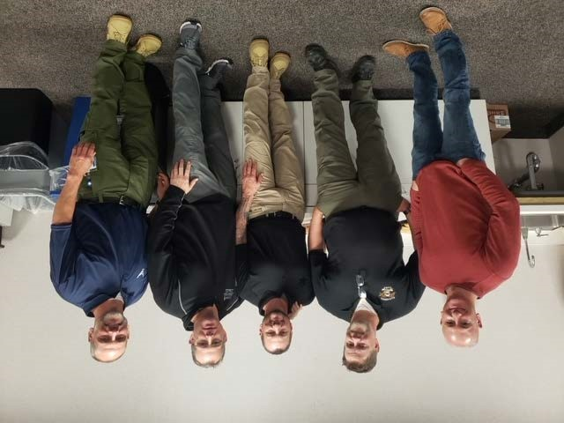
Kevin Olin is recently retired from the Janesville Police Department. he served 30 years at JPD and retired as a school resource officer. Kevin served on the SWAT team from 2006-2022. He retired from SWAT as an assistant team leader. Kevin has worked as an EMS provider throughout his career. Kevin has instructor certifications in multiple disciplines.
Jason Kelley is recently retired from the Beloit Police Department. Jason spent 26 years at BPD serving on the SWAT team for 25 years. He is an instructor in multiple disciplines including ALERRT, WPCC, and CRASE. he has been instructing for MHS in the Trauma Preparedness Center since 2015.
Mike Blaser is a Lieutenant at the Janesville Police Department. He has been in law enforcement 25 years. He has a master's degree in Organizational Change Leadership. He served on the SWAT team for almost 11 years retiring from the team as a team leader. He is certified as an instructor in rescue task force, CRASE and countless other disciplines including crisis intervention and communications.
Tim O'Leary is a recently retired Janesville Police Officer. He served 30 years in law enforcement. Tim served on the SWAT team from 1999-2021. He is a founding member of that team and retired from SWAT as the Assistant Commander. Time is an instructor in ALERRT CRASE and countless other disciplines. He has been with the Trauma preparedness Center since September of 2022.
Erin Briggs will be retiring from the Janesville Police Department in January of 2023. Erin has spent 30 years in law enforcement. He served as a crisis negotiator for more than 10 years working alongside the SWAT Team. He is retiring as a CIT officer, Hostage/Crisis Negotiator team leader. Erin worked as a Field Training Officer and in-service trainer for the past 6 years. Erin is a communications instructor as well.

